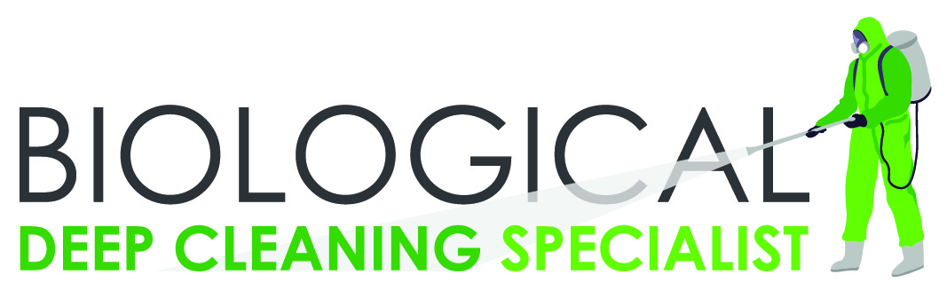 +27 +27 74 589 6867

biodeepcleaning@gmail.com

Cnr. Gamka & Coenru St, Stikland,

Western Cape, 7530

We offer: COVID-19 Disinfection Control • Deep Cleaning • Antiviral Sanitization Services

• Disinfectant Fogging Services • Hygiene Services • Disinfectant & Sanitization Services

To whom it may concern **15 May 2020**

Cleaned on: 15 May 2020

Facility: **Enter company name**

I hereby confirm that above facility was Deep cleaned, fogged and disinfected using chemicals / products which are virus killing, biodegradable, antibacterial and were manufactured to ISO 22000-2005 standards, SABS mark approved, Halaal Certificate and on request all PDS, MSDS and COA product specifications are available and these products were used at the premised of **Enter Company Name.** The product protocols used were according WHO and CDC standards and kills all germs and viruses with a 99.9% efficiency.

Next recommended clean date: **25 May 2020**

Signature: ____________________­

Abdul Saiet | General Manager



